TASK 10 – Packages, Access Modifiers and Encapsulation

Aim
To understand packages, access modifiers, getters, setters, and autoboxing in Java using the Campus Smart-Parking System.

1. Packages in Java
A package is a collection of related classes and interfaces. It helps organize code and avoid naming conflicts.
Example:
package parking;
Save the file as Vehicle.java inside the parking package folder.

2. Java Program – Vehicle.java
package parking;
public class Vehicle {
private String vehicleNo;
private String vehicleType;
public Vehicle(String vehicleNo, String vehicleType) {
this.vehicleNo = vehicleNo;
this.vehicleType = vehicleType;
}
public String getVehicleNo() {
return vehicleNo;
}
public void setVehicleNo(String vehicleNo) {
this.vehicleNo = vehicleNo;
}
public String getVehicleType() {
return vehicleType;
}
public void setVehicleType(String vehicleType) {
this.vehicleType = vehicleType;
}
public void display() {
System.out.println("Vehicle No: " + vehicleNo);
System.out.println("Vehicle Type: " + vehicleType);
}
}

3. Java Program – Main.java
import parking.Vehicle;
public class Main {
public static void main(String[] args) {
Vehicle v = new Vehicle("TN01AB1234", "Car");
v.display();
v.setVehicleType("Electric Car");
System.out.println("Updated Type: " + v.getVehicleType());
// Autoboxing
int count = 5;
Integer total = count;

System.out.println("Total Vehicles: " + total);
}
}
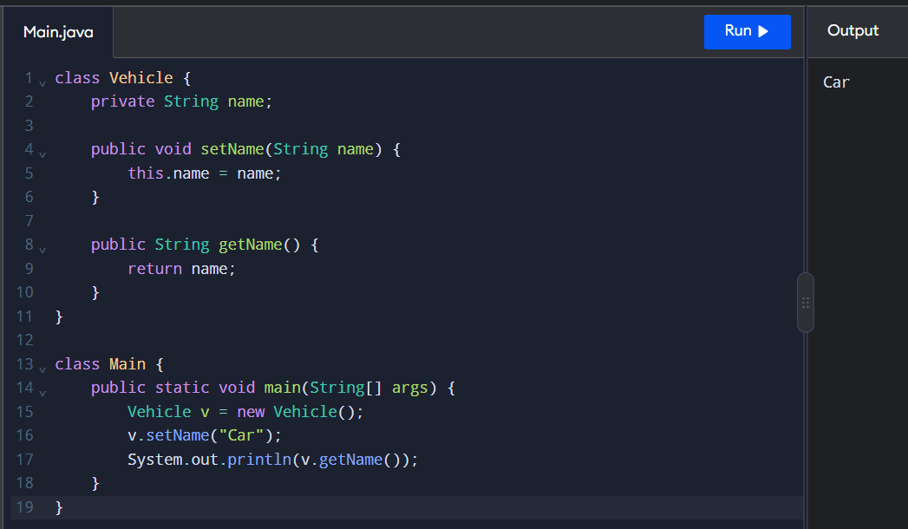

4. Expected Output
Vehicle No: TN01AB1234
Vehicle Type: Car
Updated Type: Electric Car
Total Vehicles: 5

5. Explanation
- Package: Organizes related classes. Example: parking.
- private: Allows access only within the same class.
- public: Allows access from other classes.
- protected: Allows access within the same package and through inheritance, subject to Java access rules.
- Default access: When no access modifier is specified, access is limited to the same package.
- Getter: Returns the value of a private variable.
- Setter: Updates the value of a private variable.
- Autoboxing: Automatically converts a primitive value into its corresponding wrapper object, such as int to Integer.

6.Access Modifiers Comparison

Modifier | Access
private | Same class only
Default | Same package
protected | Same package and eligible subclasses
public | Accessible from anywhere, subject to other restrictions

7. Encapsulation vs Public Fields

Encapsulation | Public Fields
Uses private variables. | Uses public variables.
Accesses data through getters and setters. | Accesses data directly.
Provides better control over data. | Provides less control over data.
Improves maintainability. | May make changes harder to manage.

Result
Packages, access modifiers, getters, setters, and autoboxing were demonstrated successfully in Java. Encapsulation protects vehicle details and allows controlled access to object data.

